**Patrick’s Log File**:

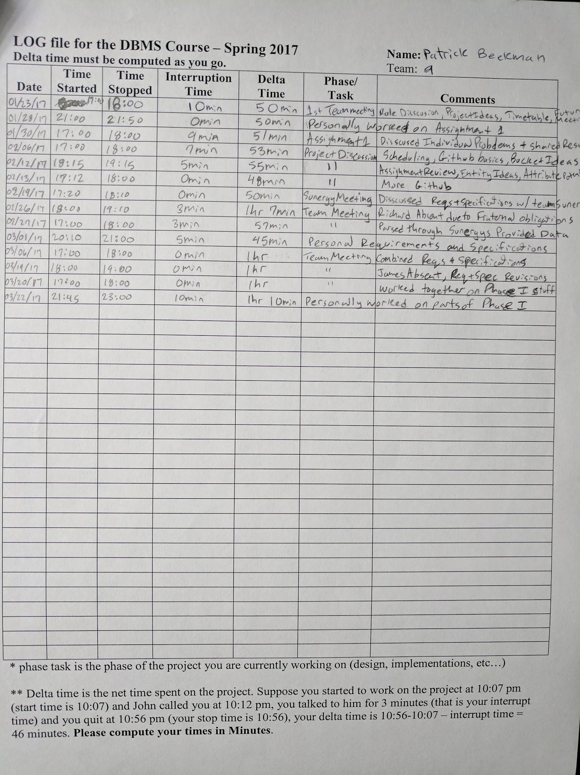

**Brian’s Log File**:

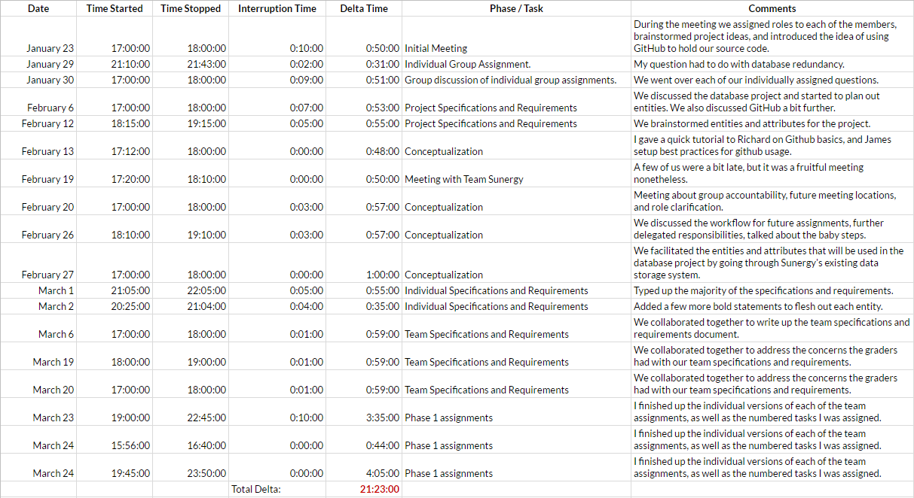

**James’ Log File**:

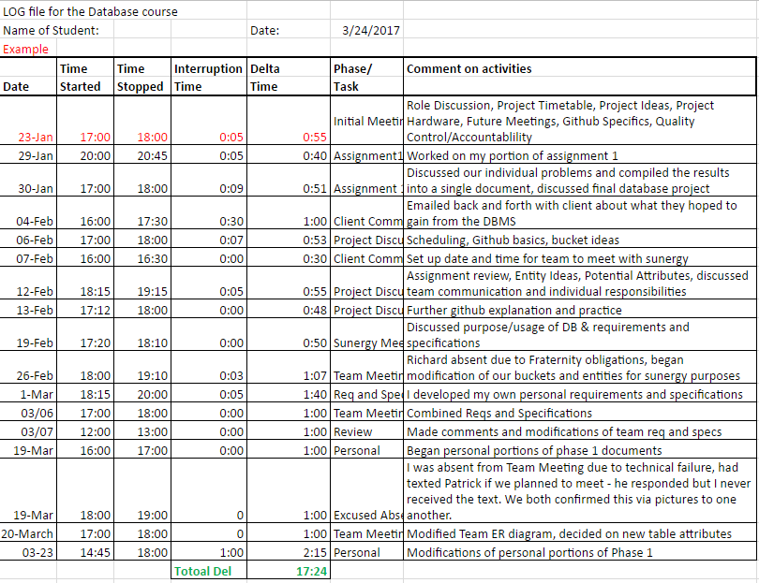

**Richard’s Log File**:

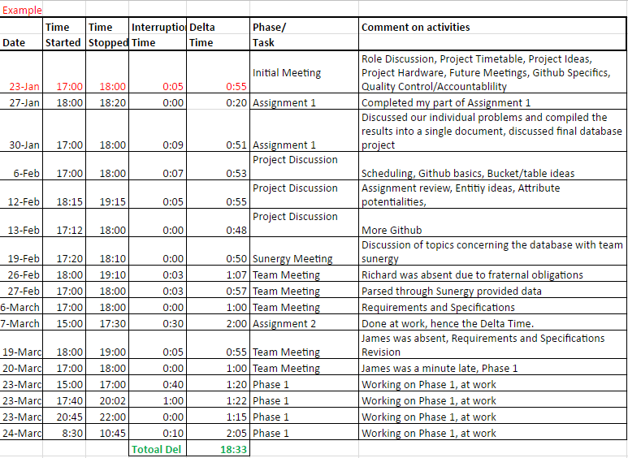

**Project Description**

Our project can be divided into two equally important aspects of design. Considering what the client wants, and how to give them as close to that as possible, and what we need as a team to reach that goal. We decided to work with Team Sunergy because, as an intercollegiate solar-car race team, it seemed they had large amounts of data pertinent to their daily activities and there was no current hub to access or manage that data. As this is a group project it was also obvious to us that we should figure out how to best work as a team to produce the best product possible, and to build skills necessary for post-university life. By combining and focusing on the development of these two things we are on our way to building a quality product.

Team Sunergy is Appalachian State’s solar car racing team, and due to their recent success, they largely run like a non-profit business. Their team is divided into 3 smaller teams (Business, Electrical, and Mechanical) and each of those teams have their own smaller sub teams. Each of these sub teams has a different goal, a number of projects, and requires any number of tools to meet their goals.

After meeting with the leadership of the team it quickly became apparent that they thought the greatest utility could be in tracking who was on these teams, what they were working on, how their budget was being spent, their carbon footprint, what tools were being used, and their race results. Our development team noticed that several of these categories were very closely related while a few were more tangential. Our desire to create the best, most tightly related, database management system possible lead us to focus on the team's, members, projects, parts, expenses, and donations. By doing so we can offer Team Sunergy the ability to monitor who is working on what, where progress is being made, how close to budget they are, how much money is coming in, what parts are missing, and much more.

Originally when our project began for almost all of us, it seemed like we didn’t have much to do at our meetings. Rather than waste our time, we began deciding how we could practice industry standards of team development through solid team values, communication, responsibilities, and tools. As such we have begun trying several agile methodologies to our practices, utilized tools such as github, google drive, and google hangouts, and focused on what each of our members required to feel satisfied in their work and as a person. It would be remiss of us to not note the positive effect this has had on us as team members, and the positive effect it has had on our relationship with our client.

**Project Objective**

The objective of this project is to create a database for Team Sunergy, Appalachian State’s solar race team. The database will primarily serve to assist them in keeping track of their members, projects, inventory, and finances.

**Project Planning and Time Line**

* 03/03 - Work on Individual Requirements & Specifications
* 03/05 - Combine our Requirements & Specifications
* 03/06 - Combine our Requirements & Specifications
* 03/07 - Turn in final copy of Requirements & Specifications
* 03/23 - Finish up Phase I
* 03/24 - Phase I Due
* 03/27 - Get comfortable with PHP and mySQL
* 04/02 - Have met with Sunergy again
* 04/08 - Have most of the project implemented in mySQL
* 04/09 - Debug our Database
* 04/16 - Finish Website, start finalizing the database
* 04/17 - Present to Sunergy
* 04/23 - Make any last changes that Sunergy suggested
* 04/24 - Finalize everything and prepare presentation
* 04/28 - Project Due

**Interview Synopsis: Sunergy Project**

As soon as all team members had arrived we made a few quick introductions before being given a tour of their warehouse. It was insightful seeing just what we were working towards. Being CS majors, the Sunergy Team was comfortable showing us the technical side of their work.

After the tour we made our way back to the front of the warehouse to their office to start discussing the database. They made it clear that the primary purpose of the database would be to manage their finances, keep a record of their members and projects, and help to keep track of their inventory. We discussed what we could at the time, having met so early on in the semester. One of our team members, being a member of Sunergy as well, has been able to maintain communication with them concerning the projects.

Towards the end of the meeting we spent a few minutes reviewing the records they kept on hand, and they gave us access to their Google Drive so that we could peruse their files at our leisure. Seeing their information and their needs allowed us to remove buckets we had conceptualized originally (such as social media and carbon footprint) and instead focus on a more tightly related cross-section of data.

**Team Sunergy Database Management System**

**(Questions Considered)**

1. What information is available for storage and management?
2. What information is Team Sunergy willing to begin collecting if storage were available?
3. What product would be of the greatest utility to Team Sunergy?
4. How will this system be managed?
5. Who will have access to this system?
6. How can this system be designed to be used in a meaningful way?
7. Of the entities, which are of interest, which are most closely related?
8. What are the benefits of storing information versus the benefits of deriving it?
9. What could our tables allow us to derive, and which derivations would be useful?
10. Do our tables need to be divided into smaller tables?
11. Are any of our attributes redundant?
12. Can any of our attributes be eliminated and instead derived?
13. What are our individual responsibilities, and what responsibilities would we like to share?
14. What tools are available to us, and which tools can assist us meaningfully?
15. Do we want to have one large meeting or two smaller ones?
16. How do we come to an agreement when we don’t all agree?
17. What do we hope to gain from this product (besides an A)?
18. How can we produce the best product possible?
19. Will the database be accessible to the client after we graduate?

**Team Responsibilities**

* Patrick Beekman
  + Team Leader
  + Will perform administrative duties and ensure that the tasks he delegates will be completed on time.
  + Help resolve team conflicts
* Brian Smith
  + Support Manager
  + Perform technology related tasks, such as introducing new technologies that are beneficial to the group (and ensure that the team is comfortable with using them).
  + Will develop hard copies of all diagrams using LaTeX.
* James Ward
  + Product Manager
  + Responsible for delegating tasks and giving the final “OK” for merging code.
* Richard Winzenried
  + Quality/Process Manager
  + Write unit tests for the code that ensures the product functions at a high level of quality.
  + Will test for bugs and create issues of those bugs if needed.

**Name of Group Communicator**

**Group communicator**: Brian was the communicator for the group.

**Patrick Beekmans Schema Diagram for the Team Sunergy Database**

MEMBER

|  |  |  |  |  |  |
| --- | --- | --- | --- | --- | --- |
| bannerID | memName | memEmail | memPhoneNo | memCollege | memMajor |
| memClass | HAMcallSign | shirtSize | roleTitle | membershipStatus | |

DONATION

|  |  |  |  |  |  |
| --- | --- | --- | --- | --- | --- |
| donationID | donationType | receivedDate | amount | donatedFrom | reason |

PUCHASE

|  |  |  |  |  |  |
| --- | --- | --- | --- | --- | --- |
| purchaseID | orderDate | arrivalStatus | arrivalDate | purhcaseType | quantityRequired |
| quantityOrdered | price/unit | purchasePriority | itemName | purhcaseFrom | |

SUBTEAM

|  |  |  |
| --- | --- | --- |
| teamName | parentTeam | purpose |

PROJECT

|  |  |  |  |  |  |
| --- | --- | --- | --- | --- | --- |
| projectName | startDate | dueDate | completedDate | projDesc | projPriority |

PART

|  |  |  |  |  |  |
| --- | --- | --- | --- | --- | --- |
| partNo | partName | quantity | category | partLocation | partManufacturer |

* **A PROJECT may have many MEMBERS**
* **A PROJECT may use many PARTS**
* **A PROJECT must have at least one SUBTEAM working on it**
* **We would like to find out how many people are working on a PROJECT**
* **We would like to find out which SUBTEAM owns a PROJECT**
* **We would like to find out which PARTS are being used by a PROJECT**
* **We would like to find out which MEMBER is supervising a PROJECT**
* **A MEMBER must be working on at least one PROJECT**
* **A MEMBER may have membership in one or many SUBTEAMS**
* **A MEMBER may rent many PARTS**
* **A SUBTEAM must have at least one MEMBER with membership**
* **A SUBTEAM may be working on many PROJECTS**
* **A SUBTEAM may make many PURCHASES**
* **A SUBTEAM may receive many DONATIONS**
* **A SUBTEAM may require many PARTS**
* **We would like to find the total number of people on a team**
* **We would like to find the number of PROJECTS being worked on by a team**
* **We would like to find the total PURCHASES for a team**
* **We would like to find the total DONATIONS given to a team**
* **A PURCHASE may be made by many SUBTEAMS**
* **A PURCHASE may be of many types of PARTS**
* **We would like to find the total cost of a set of PARTS**
* **A DONATION may be made to many SUBTEAMS**
* **A DONATION may be donated of many PARTS**
* **A PART may be of donated as one DONATION**
* **A PART may be one type of PURCHASE**
* **A PART may be rented by many MEMBERS**
* **A PART must be used by at least one PROJECT**
* **A PART may be required by many SUBTEAMS**
* **We want to find how a PART is being used**
* **We want to find out where a PART is being used**
* **We want to find out the total price of the PART**

**Brian Smith’s Schema Diagram for the Team Sunergy Database**

**MEMBER**

|  |  |  |  |  |  |
| --- | --- | --- | --- | --- | --- |
| Banner ID | Name | Email | Phone number | College | Member Status |
| Major | Class | HAM Call Sign | Shirt Size | Position | Sub Team |

**PURCHASE**

|  |  |  |  |  |  |
| --- | --- | --- | --- | --- | --- |
| Purchase ID | Order Date | Purchase Name | Arrival Date | Purchase Type | Purchased From |
| Quantity Ordered | Purchase Cost | Purchase Priority |  |  |  |

**Note**: I removed the attributes *Arrival Status*, *Expected Arrival Date*, and *Quantity Requested* since they’re redundant. I also changed the name of the attribute *Unit Price* to *Purchase Cost*, since I would like to derive the cost of each part purchased.

**DONATION**

|  |  |  |  |  |  |
| --- | --- | --- | --- | --- | --- |
| Donation ID | Donation Type | Date Received | Amount | Donated From | Donation Reason |

**Note**: I decided to rename the attribute *Type of Donation* to *Donation Type*, and *Reason* to *Donation Reason*.

**SUB TEAM**

|  |  |  |
| --- | --- | --- |
| Team Name | Parent Team | Team Purpose |

**PROJECT**

|  |  |  |  |  |  |
| --- | --- | --- | --- | --- | --- |
| Project Name | Start Date | Due Date | Completion Date | Project Purpose | Project Priority |

**PART**

|  |  |  |  |  |  |
| --- | --- | --- | --- | --- | --- |
| Part ID | Part Name | Part Quantity | Category | Location | Manufacturer |

**Requirements:**

* **A MEMBER may rent more than one PART on a certain date.**
* **A MEMBER must be working on more than one PROJECT and they have a start date for each PROJECT.**
* **A MEMBER may be a member of more than one SUB TEAM and they have a join date for each SUB TEAM.**
* **A PURCHASE may be made by more than one SUB TEAM** (I removed the attribute that was apart of this relationship because it was redundant with the key Purchase ID.)
* **A PURCHASE may be more than one type of PART** (I removed the attribute that was apart of this relationship because it didn’t make sense.)
* **A DONATION may be received by many SUB TEAMS on a certain date.**
* **A DONATION may consist of more than one PART** (I changed the relationship here from Donated to Type.)
* **A SUB TEAM must have more than one MEMBER that started on a certain date.**
* **A SUB TEAM may make more than one PURCHASE** (I removed the attribute that was apart of this relationship because it was redundant with the key Purchase ID.)
* **A SUB TEAM may be working on more than one PROJECT that’s assigned on a certain date.**
* **A SUB TEAM may receive more than one DONATION on a certain date.**
* **A SUB TEAM may acquire more than one PART on a certain date.**
* **A PROJECT may be worked on by more than one MEMBER where each member starts on a certain date.**
* **A PROJECT must be worked on by more than one SUB TEAM where each sub team has a certain start date.**
* **A PROJECT may use more than one PART on a certain date.**
* **A PART may be rented by more than one MEMBER on a certain date.**
* **A PART must be used in more than one PROJECT on a certain date.**
* **A PART may be acquired by more than one SUB TEAM on a certain date.**
* **A PART may be a type of PURCHASE**
* **A PART may be a type of DONATION**

**Note**: We would like to find out which SUB TEAMS a MEMBER is on.

**Note**: We would like to find the total amount of money spent on a PART.

**Note**: We would like to find the total number of MEMBERS that are on a SUB TEAM.

**Note**: We would like to find the total number of PROJECTS being worked on by a SUB TEAM.

**Note**: We would like to find all of the PURCHASES made by a SUB TEAM.

**Note**: We would like to find out how many MEMBERS are working on a PROJECT.

**Note**: We would like to find out which SUB TEAMS own a PROJECT.

**Note**: We would like to find out which PARTS are being used by a PROJECT.

**Note**: We would like to find out which MEMBER is supervising a PROJECT.

**Note**: We would like to find out how the PART is used.

**Note**: We would like to find out the price of the PART.

**Note**: We would like to find out where the PART was purchased from.

**James Ward’s Schema Diagram for the Team Sunergy Database**  
  
**MEMBER:**

|  |  |  |  |  |  |  |  |  |  |
| --- | --- | --- | --- | --- | --- | --- | --- | --- | --- |
| BannerID | Name | Email | Phone_Number | College | Major | Class | Shirt_Size | Position | Membership_Status |

**SUBTEAM:**

|  |  |  |
| --- | --- | --- |
| SubName | Parent_Team | Purpose |

**PROJECT:**

|  |  |  |  |  |  |
| --- | --- | --- | --- | --- | --- |
| ProjName | Start_Date | Due_Date | Goal | Priority | Completion_Date |

**PART:**

|  |  |  |  |  |  |
| --- | --- | --- | --- | --- | --- |
| IDNumber | Part_Name | Quantity | Category | CurrLocation | Manufacturer |

**DONATION:**

|  |  |  |  |  |  |
| --- | --- | --- | --- | --- | --- |
| DonationID | Type_of_Donation | Date_Received | Amount | Donated_By | Reason_for_Donation |

**PURCHASE:**

|  |  |  |  |  |  |  |  |  |  |
| --- | --- | --- | --- | --- | --- | --- | --- | --- | --- |
| PurchaseID | Order_Date | Arrival_Status | Expected_Arrival_Date | Type_of_Purchase | Quantity_Requested | Price_Per_Unit | Priority | Item_Name | Purchased_From |

There are attributes that are not included as they will be resolved once we build the relationships between tables and can derive certain information. We will address those items in bold below.

* **Each MEMBER may rent many PARTS**
* **A MEMBER may be working on many PROJECTS**
* **A MEMBER may lead many PROJECTS**
* **A MEMBER may maintain membership in many SUBTEAMS**
* **A MEMBER may lead one SUBTEAM**
* **We would like to keep track of the subteam a member is on**
* **A PROJECT may have many MEMBERS working on it**
* **A PROJECT must be being worked on by at least one SUBTEAM**
* **A PROJECT may use many PARTS**
* **A PROJECT may be lead my one MEMBER.**
* **We would like to keep track of how many people are working on a projec**
* **We would like to keep track of which parts are being used by a project**
* **A SUBTEAM must consist of at least one MEMBER**
* **A SUBTEAM may be working on many PROJECTS**
* **A SUBTEAM may receive many DONATIONS**
* **A SUBTEAM may make many PURCHASES**
* **A SUBTEAM may require many PARTS**
* **A SUBTEAM must be lead by one MEMBER**
* **We would like to be able to find out the number of people that are part of a subteam**
* **We would like to be able to find out the number of projects being worked on by a team**
* **We would like to be able to find out total expenses of each team**
* **A PURCHASE must be made by one SUBTEAM**
* **A PURCHASE may buy one and only on PART**
* **We would like to be able to find out the total cost of a set of parts (quantity * price per unit)**
* **A DONATION may be received by many SUBTEAMS**
* **A DONATION may donate many PARTS**
* **We would like to be able to find out how many donations have been made by a particular person/manufacturer/group**
* **A PART may be donated by many DONATIONS**
* **A PART may bought by many PURCHASES**
* **A PART may be used by many PROJECTS**
* **A PART may be used by many SUBTEAMS**
* **A PART may be used by many MEMBERS**
* **We would like to be able to find out where a part is currently being used**
* **We would like to be able to find out the cost of a part (through purchase)**
* **We would like to be able to find out where the part was purchased from (through purchase)**

**Note:** A member may not be actively participating in projects or be on a subteam and may instead be an alumni or serving as an advisor to the team.

**Note:** A part may be donated multiple times by several benefactors, this is allowed by the part table having a quantity field.

**Note:** Bold statements beginning with ‘keep track of’ or ‘would like to be able to find’ represent derived information

**Richard Winzenried’s Schema Diagram for the Team Sunergy Database**

MEMBER (Comment: was previously ROSTER. Changed to MEMBER for singularity.)

|  |  |  |  |  |  |  |  |  |  |  |
| --- | --- | --- | --- | --- | --- | --- | --- | --- | --- | --- |
| bannerID | Fname | Mname | Lname | email | phone | college | major | class | Call sign | Shirt size |
| Title | Status | Subteam |

SUBTEAM

|  |  |  |
| --- | --- | --- |
| STname | ParentTeam | Description |

PROJECT

|  |  |  |  |  |  |
| --- | --- | --- | --- | --- | --- |
| Pname | startDate | dueDate | Goal | Priority | completedDate |

PART

|  |  |  |  |  |  |
| --- | --- | --- | --- | --- | --- |
| partNumber | partName | Quantity | Category | Location | Manufacturer |

PURCHASE (Comment: was previously EXPENSE/BUDGET. Split into PURCHASE and DONATION)

|  |  |  |  |  |  |  |  |
| --- | --- | --- | --- | --- | --- | --- | --- |
| purchaseID | orderDate | arrivalStatus | expectedArrivalDate | | pType | quantityRequested | quantityOrdered |
| pricePerUnit | priority | itemName | purchasedFrom |

DONATION

|  |  |  |  |  |  |
| --- | --- | --- | --- | --- | --- |
| donationID | dType | receivedDate | amount | donor | reason |

**A MEMBER must be on at least one SUBTEAM.**

**A MEMBER must work on at least one PROJECT.**

**A MEMBER may rent many PARTS.**

**A PROJECT may be worked on by many MEMBERS.**

**A PROJECT must be worked on by at least one SUBTEAM.**

**A PROJECT may use many PARTs.**

**A PART must be used by at least one PROJECT.**

**A PART may be used by many SUBTEAMs.**

**A PART may be a type of PURCHASE.**

**A PART may be a type of DONATION.**

**A PART may be rented by many MEMBERS.**

**A SUBTEAM must have at least one MEMBER.**

**A SUBTEAM may work on many PROJECTs.**

**A SUBTEAM may use many PARTS.**

**A SUBTEAM may receive many DONATIONs.**

**A SUBTEAM may make many PURCHASEs.**

**A PURCHASE may be made by many SUBTEAMS.**

**A type of PURCHASE may be one or many PARTs.**

**A DONATION may be received by many SUBTEAMS.**

**A DONATION may contain many PARTs.**

**Patrick’s ER Diagram**

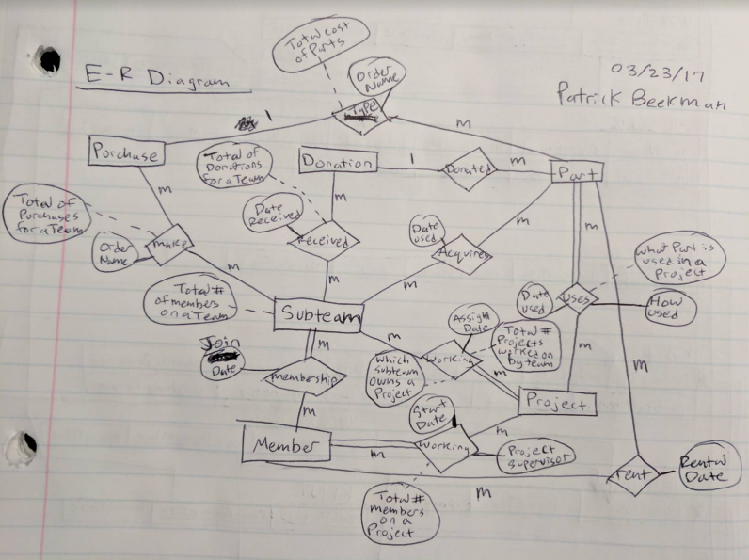

**Brian’s ER Diagram**

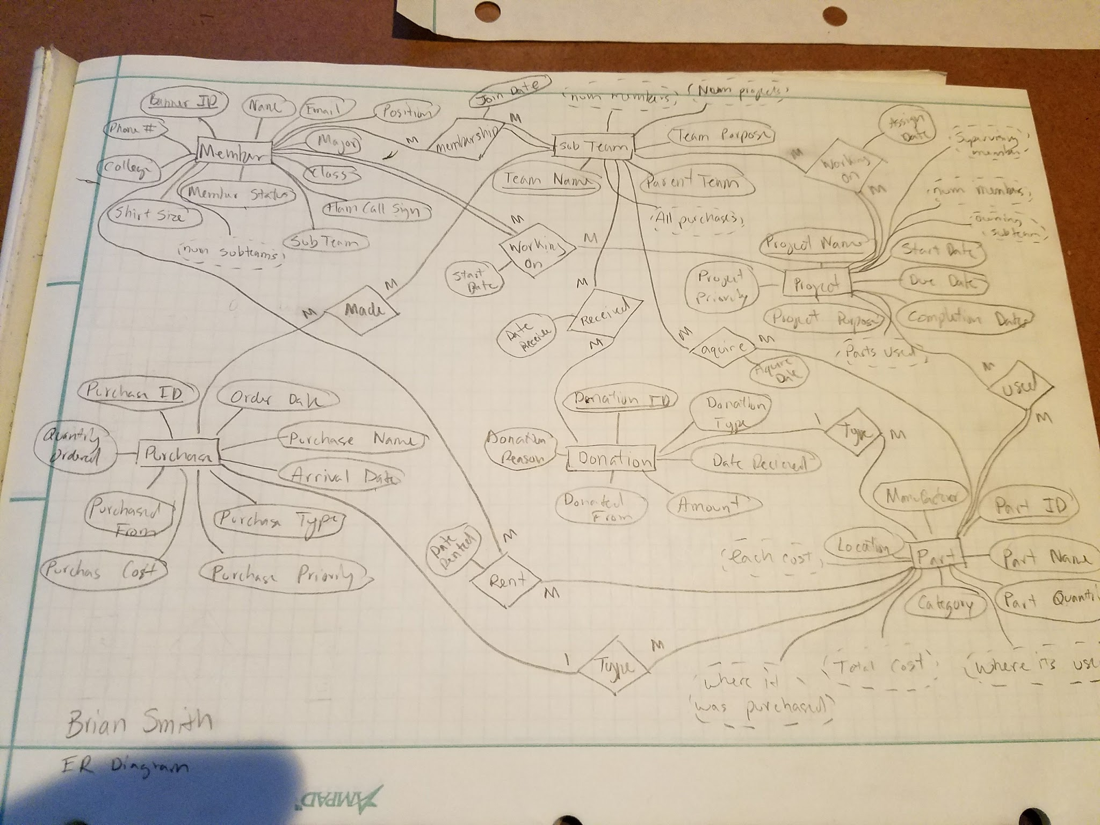

**James’ ER Diagram**

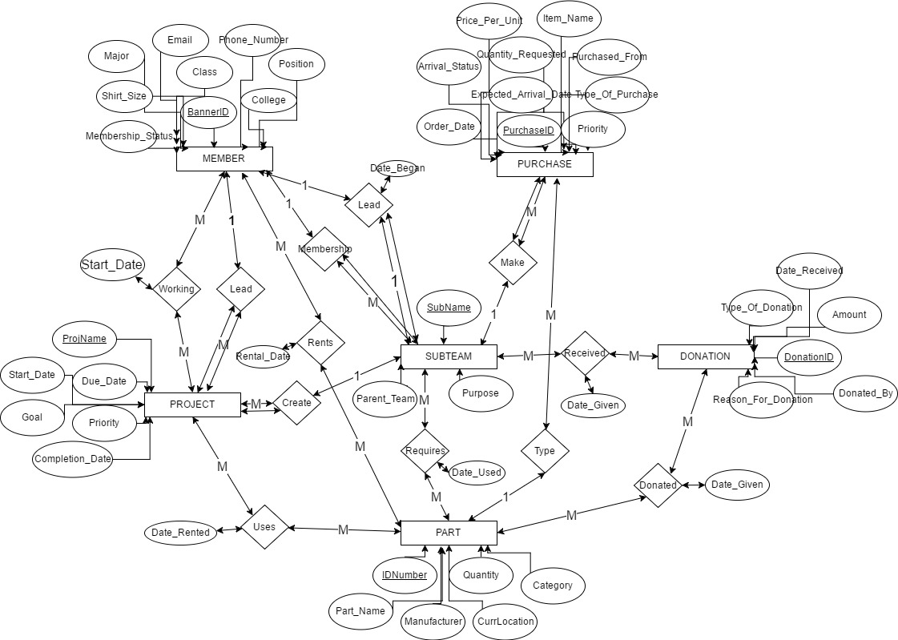

**Richard’s ER Diagram**

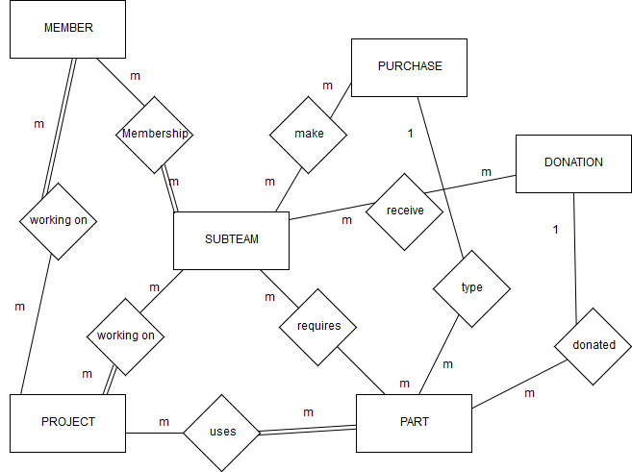

**Patrick’s Relational Schema**

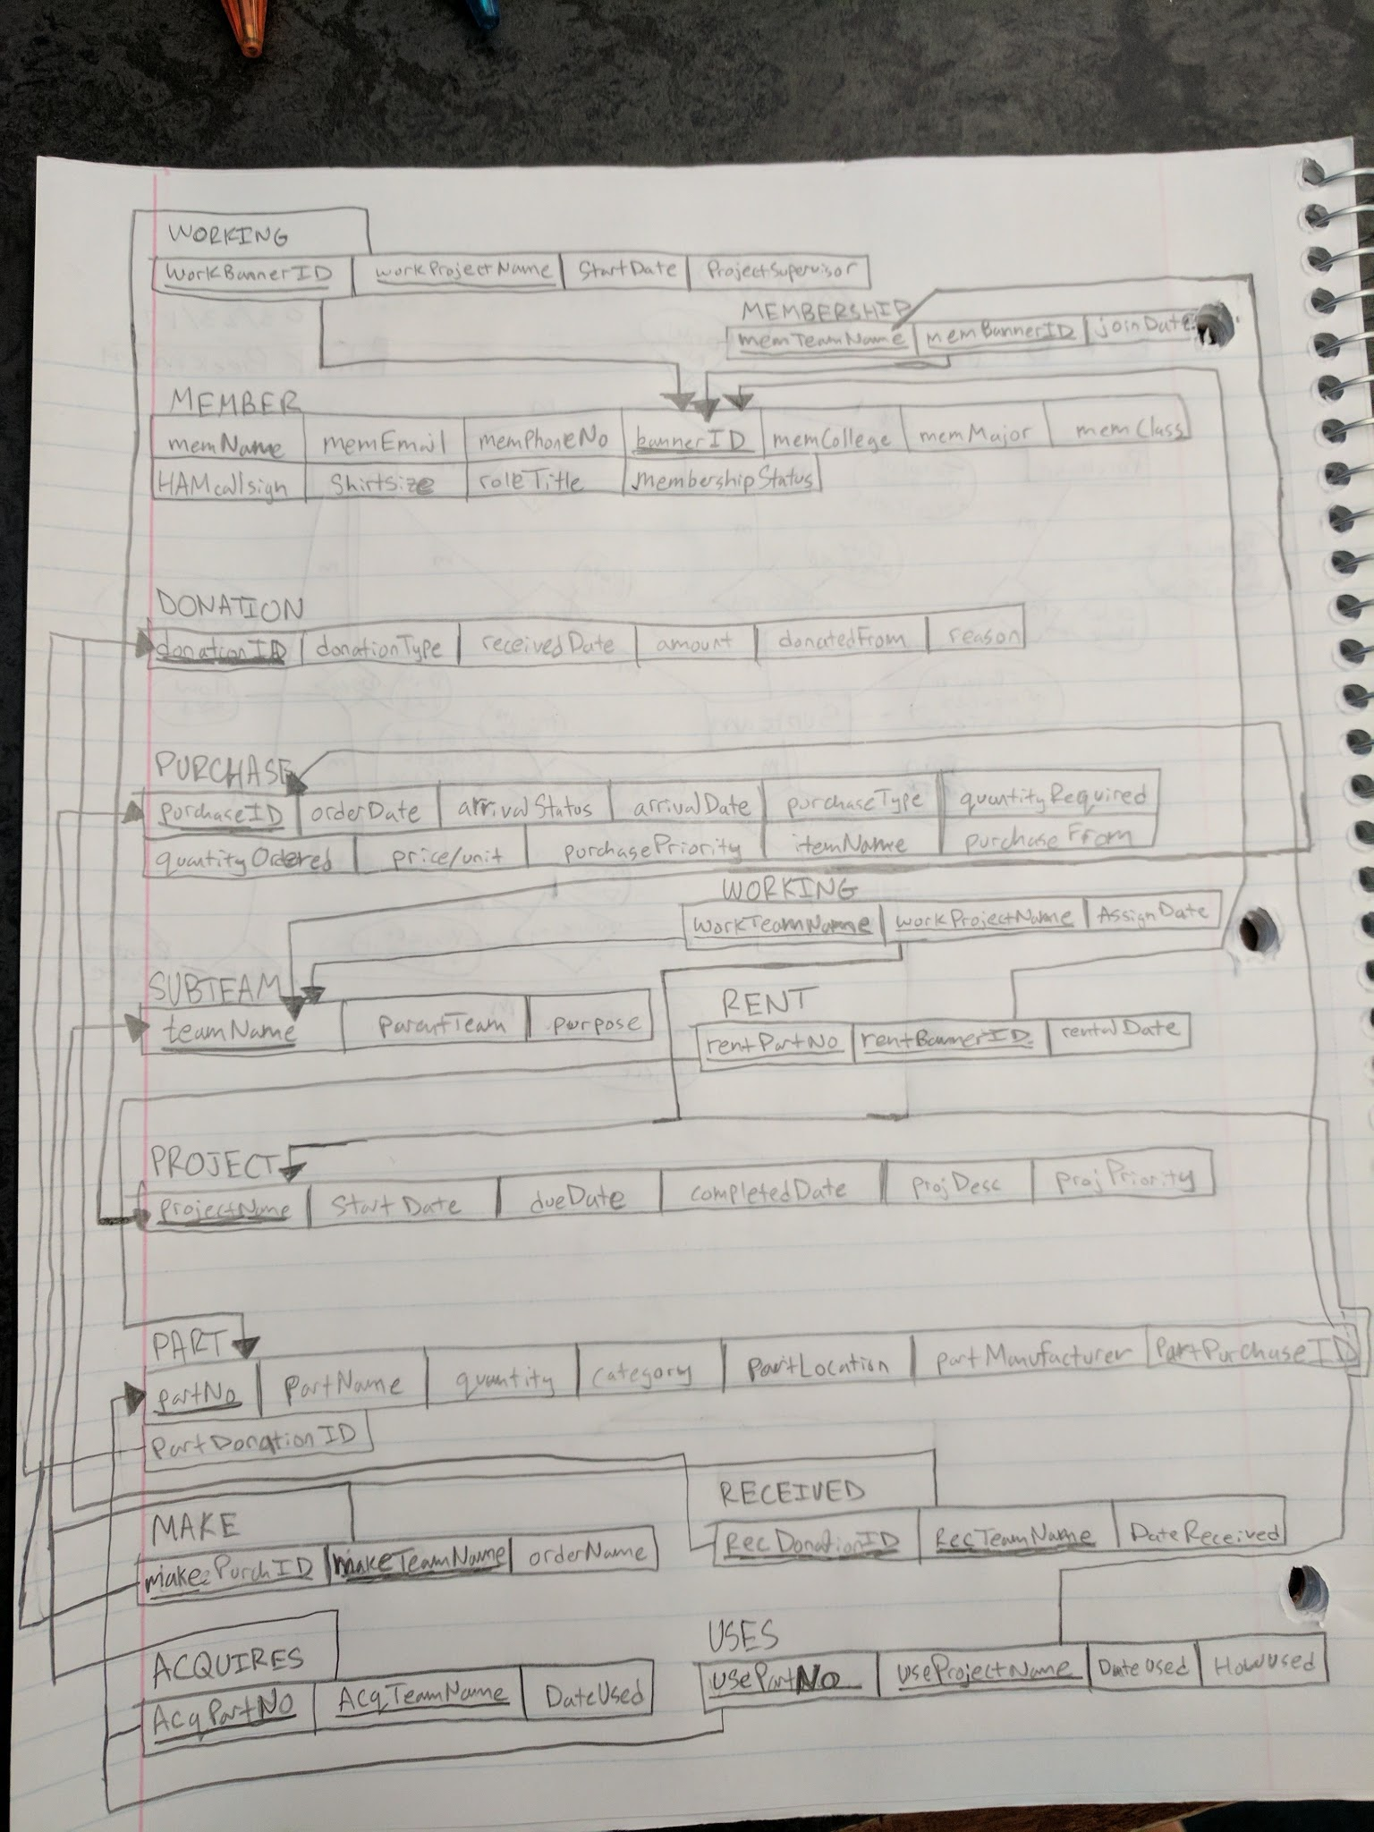

**Brian’s Relational Schema**

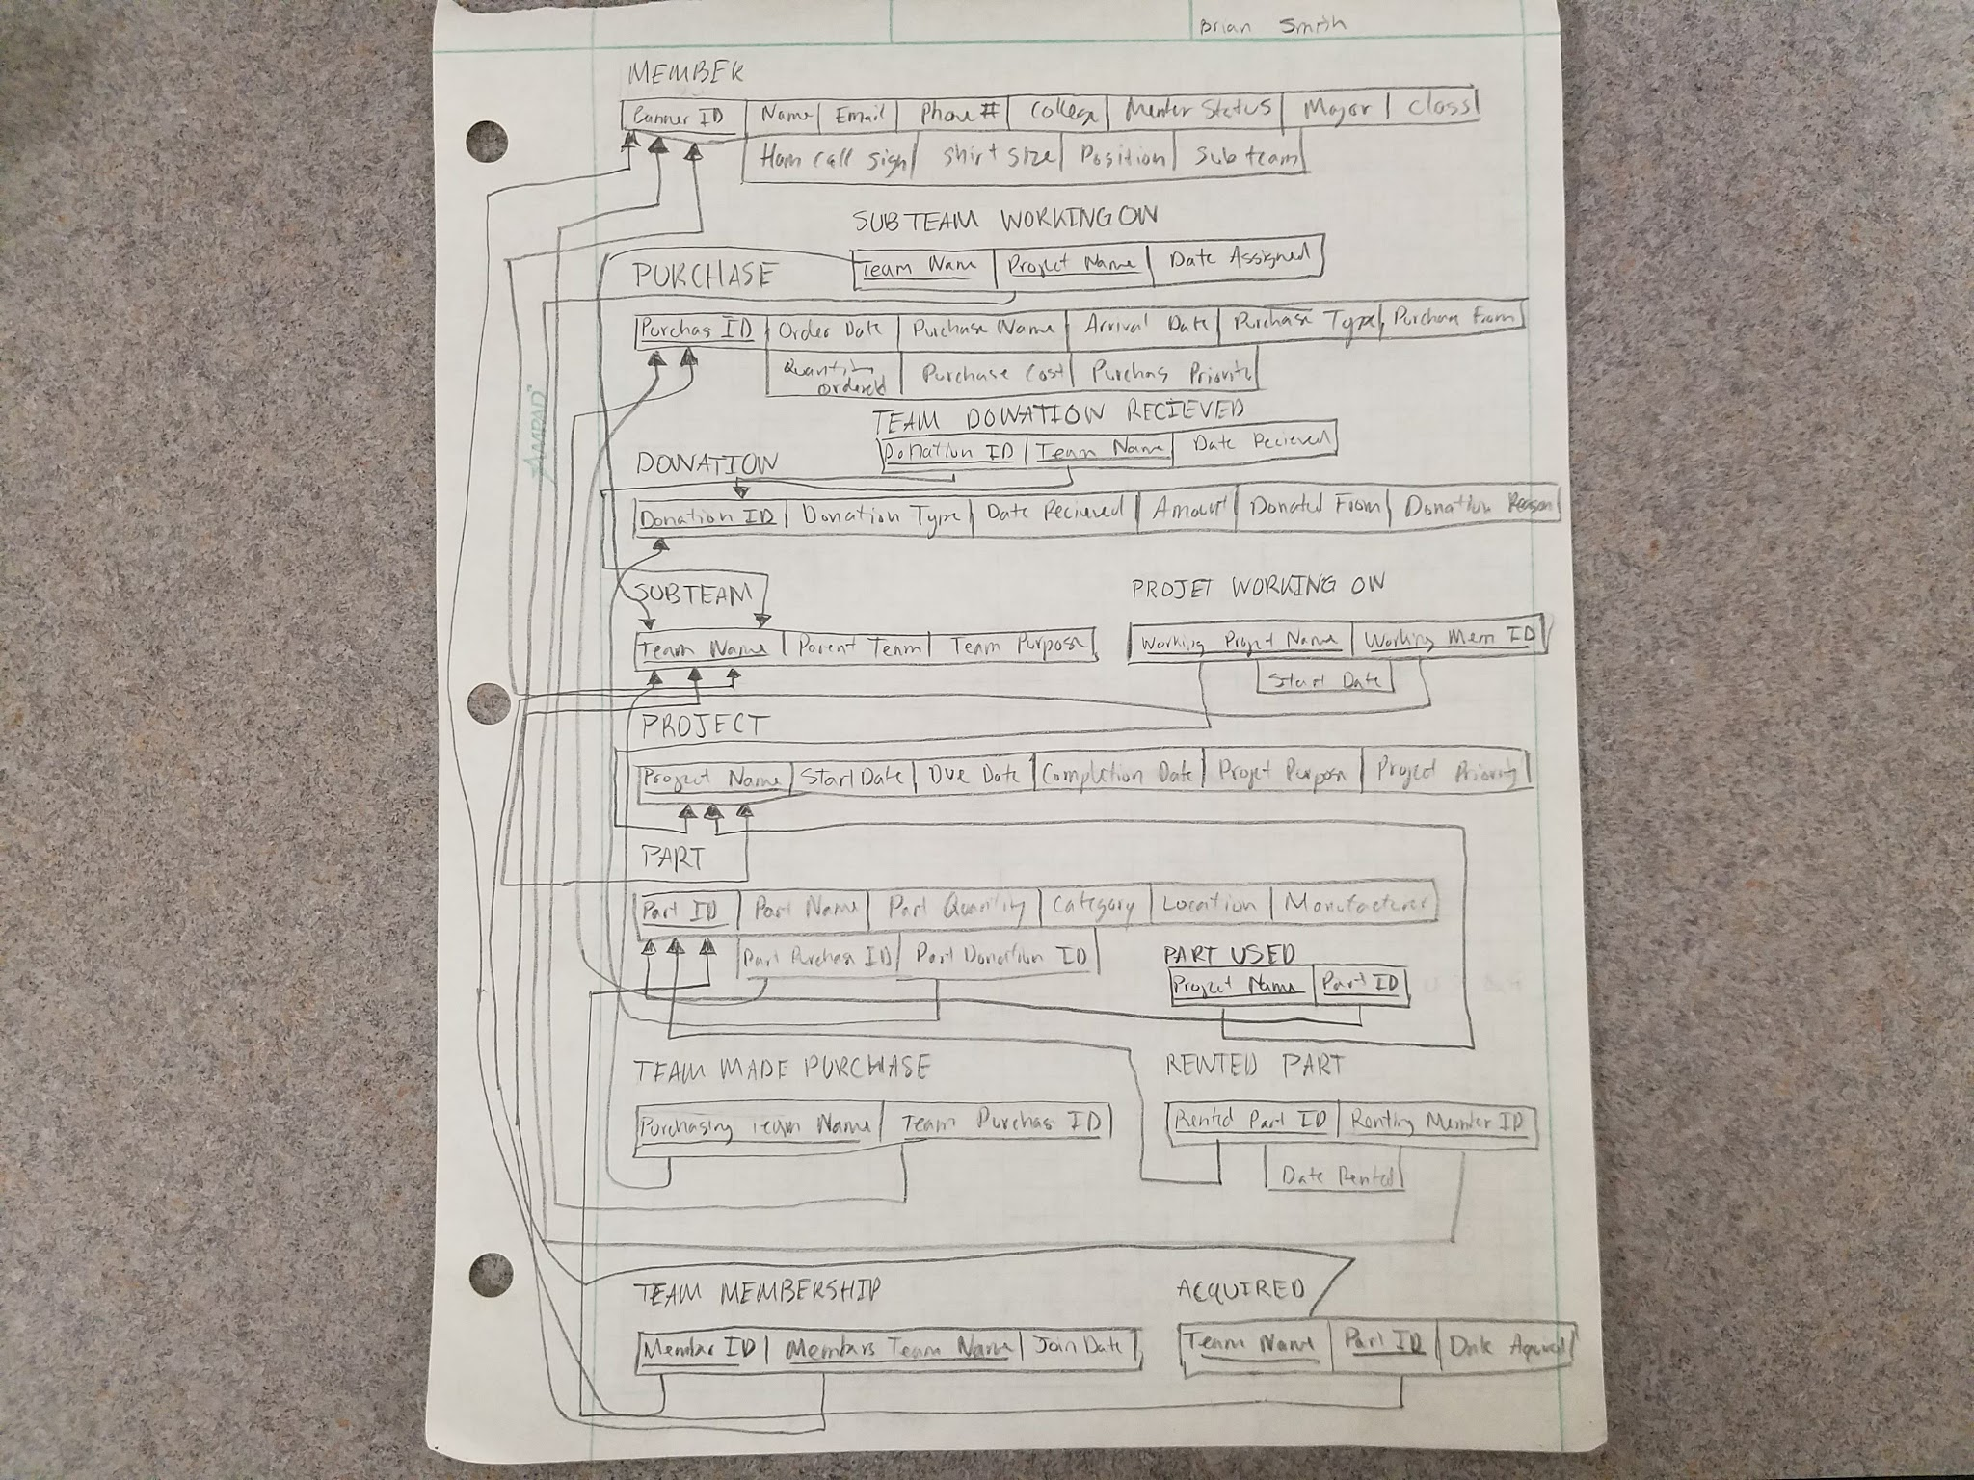

**James Relational Schema**

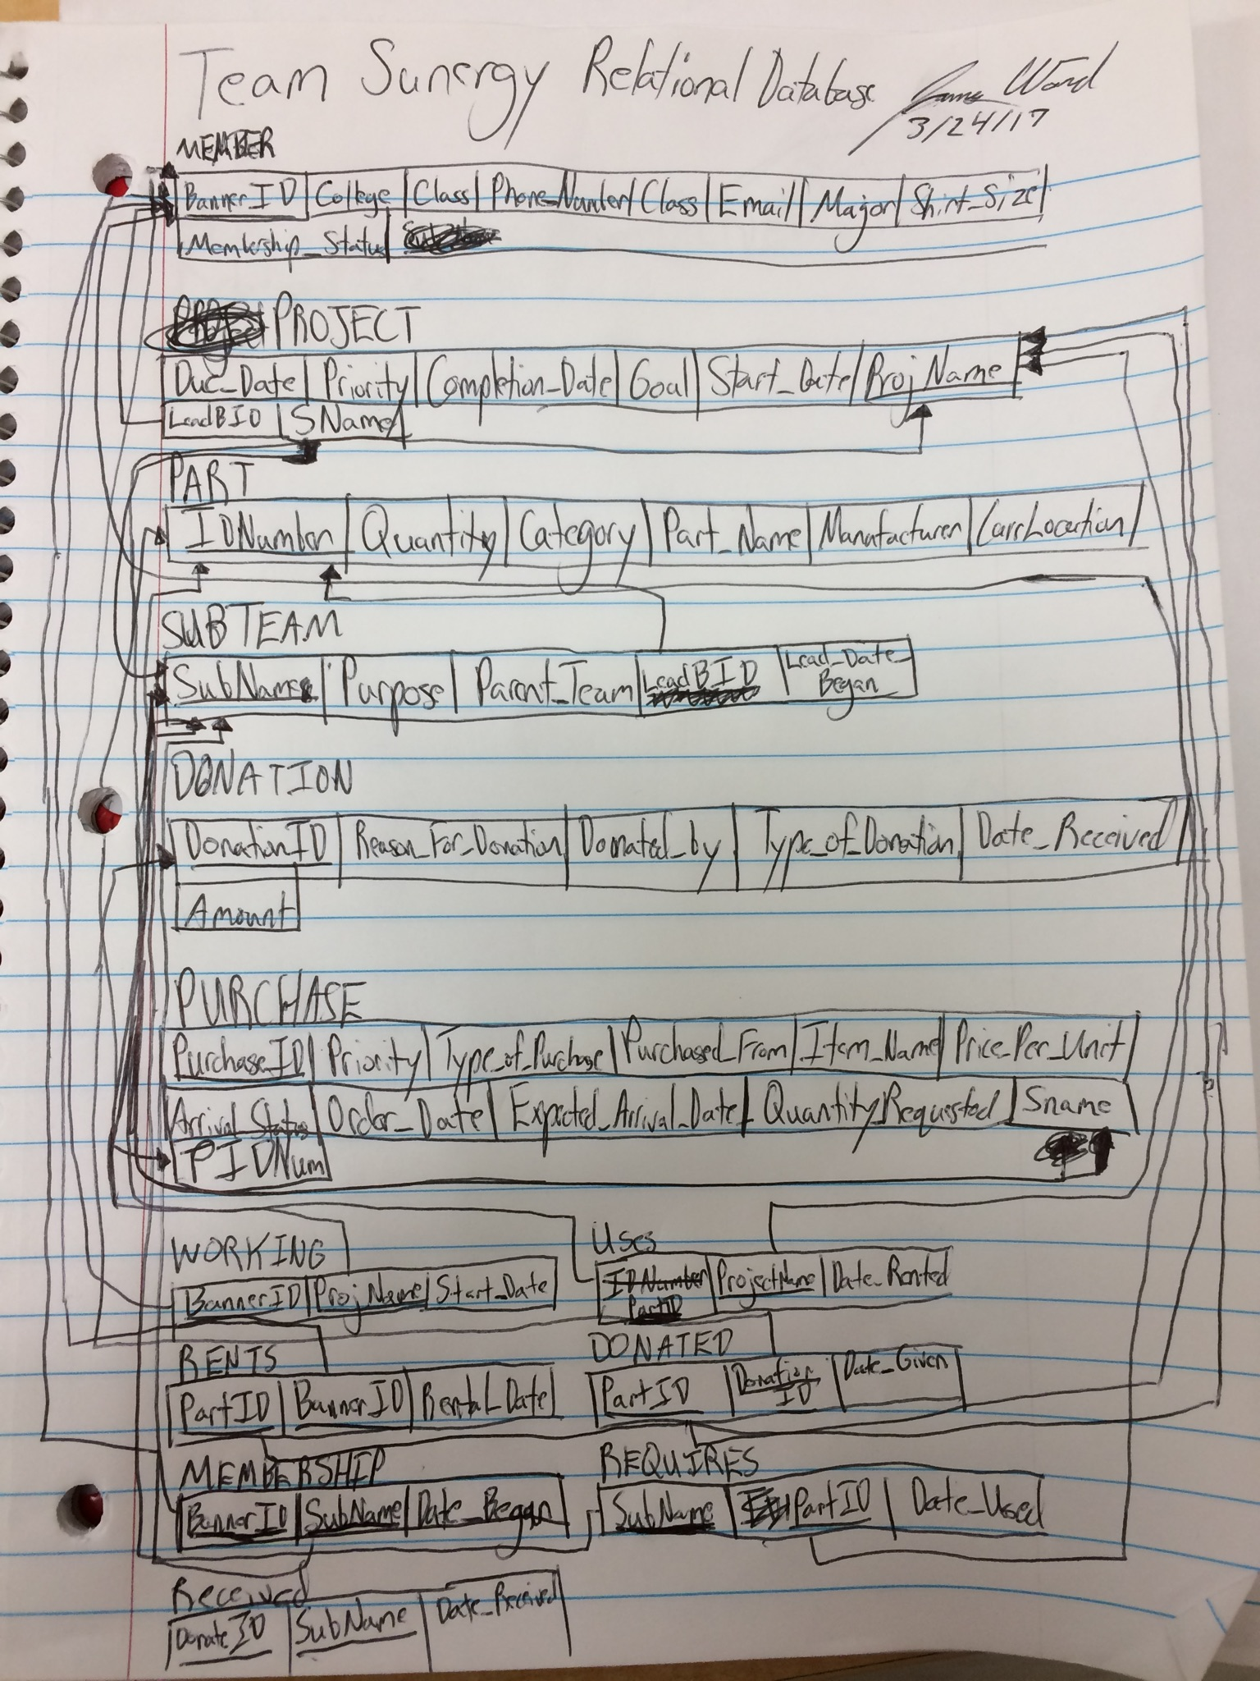

**Richard’s Relational Schema**

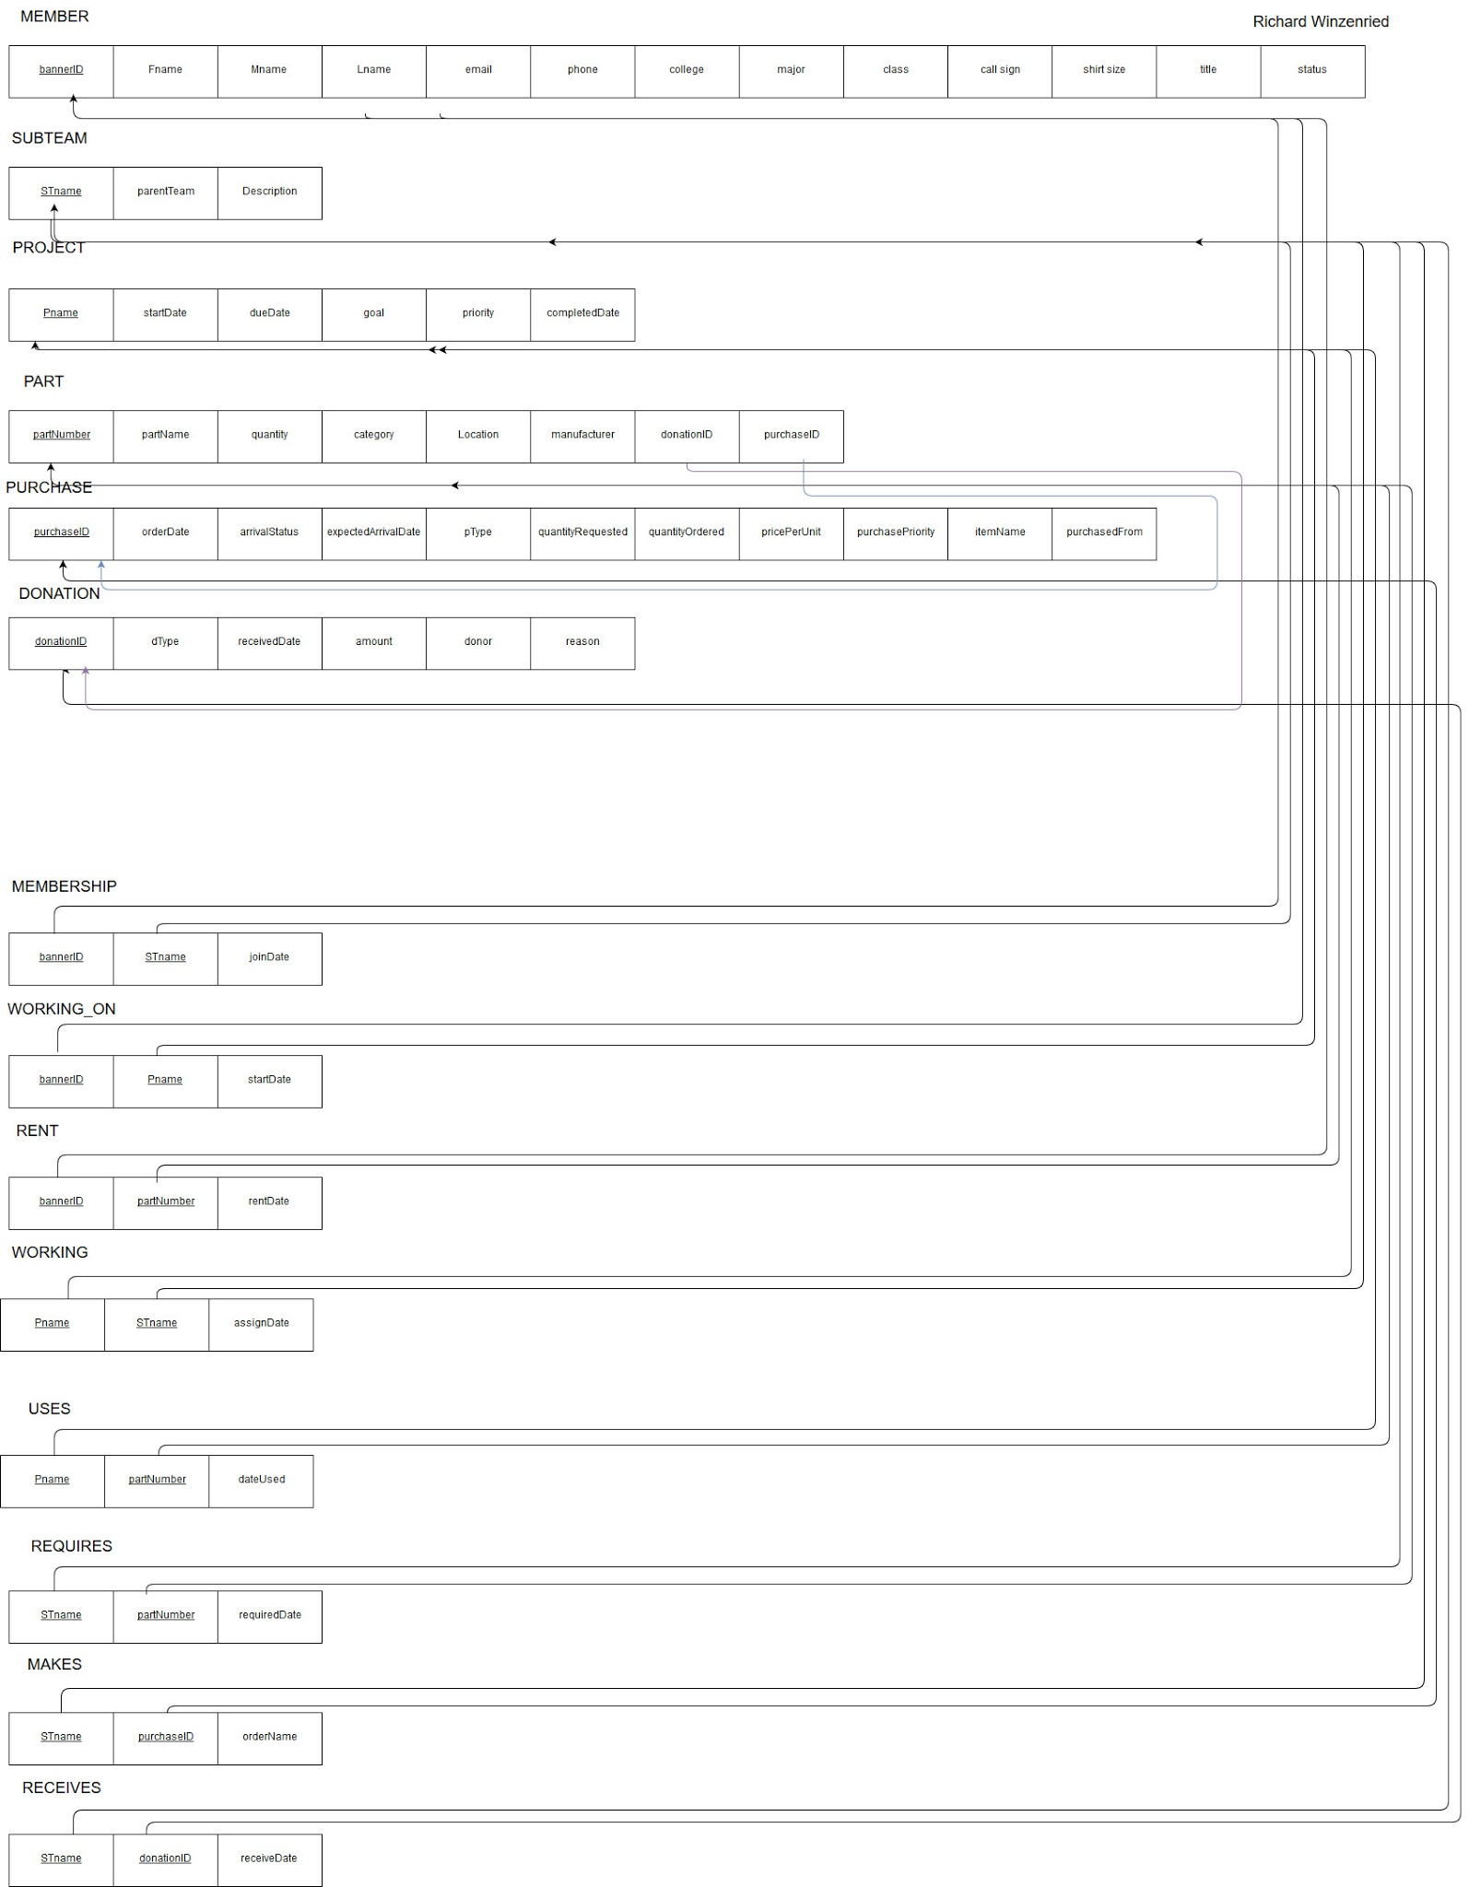

**Team Schema**

**MEMBER**

|  |  |  |  |  |  |
| --- | --- | --- | --- | --- | --- |
| Banner ID | Name | Email | Phone number | College | Member Status |
| Major | Class | HAM Call Sign | Shirt Size | Position | Sub Team |

**PURCHASE**

|  |  |  |  |  |  |
| --- | --- | --- | --- | --- | --- |
| Purchase ID | Order Date | Purchase Name | Arrival Date | Purchase Type | Purchased From |
| Quantity Ordered | Purchase Cost | Purchase Priority |  |  |  |

**Note**: We decided to remove the attributes *Arrival Status*, *Expected Arrival Date*, and *Quantity Requested* since they’re redundant. We also changed the name of the attribute *Unit Price* to *Purchase Cost*, since we would like to derive the cost of each part purchased.

**DONATION**

|  |  |  |  |  |  |
| --- | --- | --- | --- | --- | --- |
| Donation ID | Donation Type | Date Received | Amount | Donated From | Donation Reason |

**SUB TEAM**

|  |  |  |
| --- | --- | --- |
| Team Name | Parent Team | Team Purpose |

**PROJECT**

|  |  |  |  |  |  |
| --- | --- | --- | --- | --- | --- |
| Project Name | Start Date | Due Date | Completion Date | Project Purpose | Project Priority |

**PART**

|  |  |  |  |  |  |
| --- | --- | --- | --- | --- | --- |
| Part ID | Part Name | Part Quantity | Category | Location | Manufacturer |

**Requirements:**

* **A MEMBER may rent more than one PART on a certain date.**
* **A MEMBER must be working on more than one PROJECT and they have a start date for each PROJECT.**
* **A MEMBER may lead many PROJECTS**
* **A MEMBER may be a member of more than one SUB TEAM and they have a join date for each SUB TEAM.**
* **A MEMBER may lead one SUBTEAM**
* **A PURCHASE may be made by more than one SUB TEAM**
* **A PURCHASE may be more than one type of PART**
* **A DONATION may be received by many SUB TEAMS on a certain date.**
* **A DONATION may consist of more than one PART**
* **A SUB TEAM must have more than one MEMBER that started on a certain date.**
* **A SUB TEAM may make more than one PURCHASE**
* **A SUB TEAM may be working on more than one PROJECT that’s assigned on a certain date.**
* **A SUB TEAM may receive more than one DONATION on a certain date.**
* **A SUB TEAM may acquire more than one PART on a certain date.**
* **A SUBTEAM must be lead by one MEMBER**
* **A PROJECT may be worked on by more than one MEMBER where each member starts on a certain date.**
* **A PROJECT must be worked on by more than one SUB TEAM where each sub team has a certain start date.**
* **A PROJECT may be lead by one MEMBER.**
* **A PROJECT may use more than one PART on a certain date.**
* **A PART may be rented by more than one MEMBER on a certain date.**
* **A PART must be used in more than one PROJECT on a certain date.**
* **A PART may be acquired by more than one SUB TEAM on a certain date.**
* **A PART may be a type of PURCHASE**
* **A PART may be a type of DONATION**

**Note**: We would like to find out which SUB TEAMS a MEMBER is on.

**Note**: We would like to find the total amount of money spent on a PART.

**Note**: We would like to find the total number of MEMBERS that are on a SUB TEAM.

**Note**: We would like to find the total number of PROJECTS being worked on by a SUB TEAM.

**Note**: We would like to find all of the PURCHASES made by a SUB TEAM.

**Note**: We would like to find out how many MEMBERS are working on a PROJECT.

**Note**: We would like to find out which SUB TEAMS own a PROJECT.

**Note**: We would like to find out which PARTS are being used by a PROJECT.

**Note**: We would like to find out which MEMBER is supervising a PROJECT.

**Note**: We would like to find out how the PART is used.

**Note**: We would like to find out the price of the PART.

**Note**: We would like to find out where the PART was purchased from.

**Note:** We added a relationship between Member and Subteam to show leadership of the teams.

**Note:** We added a relationship between Member and Project to show leadership of the projects.

**Team ER Diagram**

Team Sunergy ER Diagram.png

**Team Relational Schema**

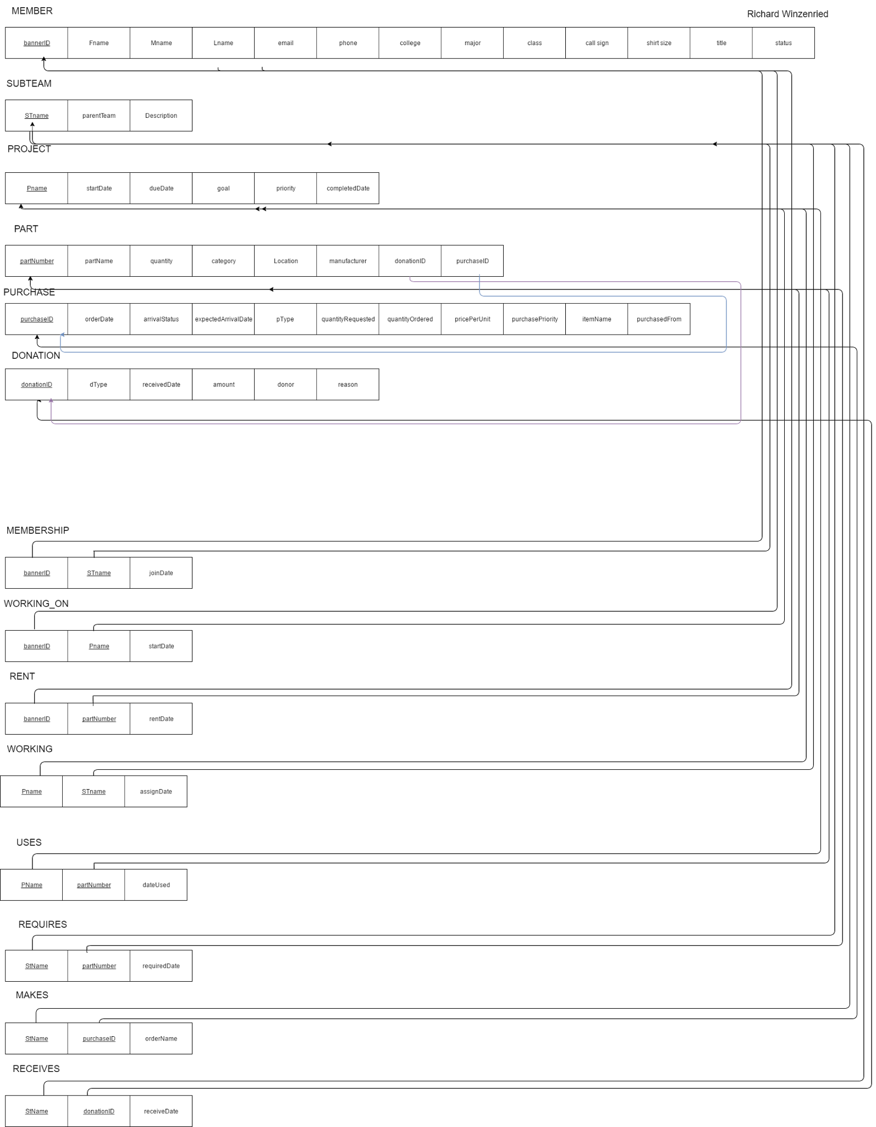

**Catalog**

**MEMBER**

bannerID int char(9)

memName string varchar(25)

memEmail string varchar(50)

memPhoneNum string char(10)

memCollege string varchar(50)

memMajor string varchar(50)

memClass string varchar(8)

shirtSize string varchar(2)

roleTitle string varchar(25)

membershipStatus bit bit()

**DONATION**

donationID int int()

donationType string varchar(25)

receivedDate date date()

amount int int()

donatedFrom string varchar(50)

reason string varchar(255)

**PURCHASE**

purchaseID int int()

orderDate string date()

arrivalStatus boolean bit()

arrivalDate string date()

purchaseType string varchar(25)

quantityRequired int int()

quantityOrdered int int()

price/unit double decimal()

puchasePriority int int()

itemName string varchar(50)

purchasedFrom string varchar(50)

**SUBTEAM**

teamName string varchar(25)

parentTeam string varchar(25)

purpose string varchar(255)

**PROJECT**

projectName string varchar(25)

startDate string date()

dueDate string date()

completedDate string date()

projDesc string varchar(255)

projPriority int int()

**PART**

partNumber int varchar(15)

partName string varchar(25)

quantity int int()

category string varchar(25)

partLocation string varchar(25)

partManufacturer string varchar(25)

**M:M Relationships**

**MEMBERSHIP (MEMBER to SUBTEAM)**

bannerID int char(9)

SubteamName string varchar(25)

joinDate

**WORKING_ON (MEMBER to PROJECT)**

bannerID int char(9)

PName string varchar(25)

startDate string date()

**RENT (MEMBER to PART)**

bannerID int char(9)

partNumber int varchar(15)

rentDate string date()

**WORKING (PROJECT to SUBTEAM)**

PName string varchar(25)

SubteamName string varchar(25)

assignDate string date()

**USES (PROJECT to PART)**

PName string varchar(25)

partNumber int varchar(15)

dateUsed string date

**REQUIRES (SUBTEAM to PART)**

SubteamName string varchar(25)

partNumber int varchar(15)

requiredDate string date()

**MAKE (SUBTEAM to PURCHASE)**

SubteamName string varchar(20)

purchaseID int int()

orderName string date()

**RECEIVES (SUBTEAM to DONATION)**

SubteamName string varchar(25)

donationID int int()

receiveDate string date()

**Software Applications for Implementation**

When we begin implementing the database, we’ll use MySQL to manipulate the project database that has been created for us. It’ll provide the the tools we need to create and manipulate tables, and will serve as the backend to a website interface.

The interface will be created using PHP and HTML, where PHP will allow us to interact with the database. It will be stored on the student machine in a web directory that’s accessible to our client. In the future, we plan move the database to its own server so that it remains accessible to Team Sunergy in case our web directories are removed after we graduate.

In addition, we decided to manage the project with GitHub, and so we have a private repository that will store all the code we develop. We established a workflow that requires team members to peer review each other's code submissions, which ensures that our team produces quality content.

For communication purposes we used Google Hangouts. This was the easiest method of instant messaging as we already all have Google email accounts through Appalachian State. Additionally, this also allowed us to easily maintain a quick recap of our meeting through pictures.

For the purposes of storage, transparency, and review we used Google Drive. Whenever we have team documents to create, Google Docs allowed us the ability actively review as a team.

Finally, Google Drive allowed us the ability to actively store information in a way that if any of our computers were to go down, the files themselves would be safe.